Mix ‘n’ Match - Homework
Put your answers in the boxes on the right hand side.
A  NameFormGroup code:Date Set:Date due: | The symbol for a switch | It restricts the flow of electricity in a circuit.
B | What does a resistor do? | Printed Circuit Board
C | What function does a transistor perform in a circuit? | Light Emitting Diode
D | What do you draw a circuit onto? | A light dependant resistor
E | What acid is used to etch the circuit design? | It is an internal switch
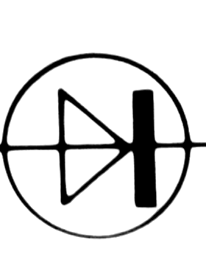  F | What does LED stand for?
G |  | 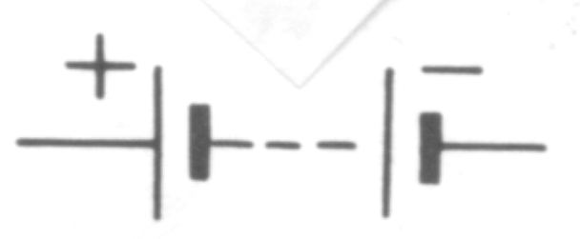  Copper
H | What sensor is dependant on light? | Is the symbol for a battery.
I | Which metal conducts electricity best? | Ferric Chloride Acid
J | What do you make a prototype of your circuit design on before making the real thing? | It is a component that is sensitive to outside forces or elements
K | What tool do you use to solder the components onto the board? | Model Board
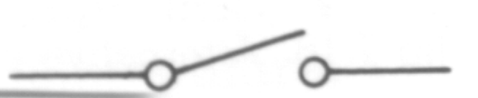  L | What is the symbol for a bulb?
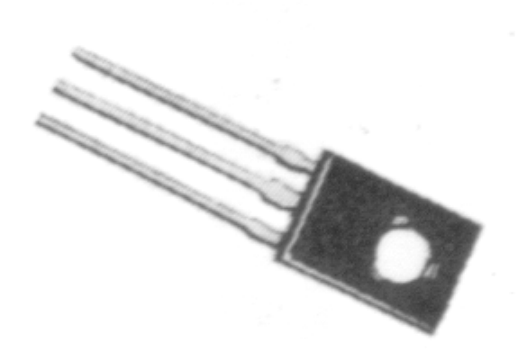  M | What is a sensor?
N | What is the symbol for a diode? | Soldering Iron
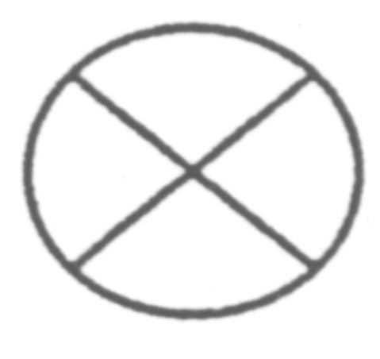O | Which is the transistor?

