Pneumatic systems are used in a large number of manufacturing situations. The are used to control a number of mechanical components and are often connected to linkages to make the linear movement more efficient. Pneumatics uses compressed air.

Safety First!
Never blow compressed air at anyone.
Connect up all the components in a system before connecting to the air supply.
Wear goggles when working with pneumatic equipment.
Keep hands out of the way of moving parts.
Ask if you are unsure.

Standard Pneumatic Equipment:

A Single Acting Cylinder
B Double Acting Cylinder
C Three Port Valve
D Five Port Valve
E Flow Control Valve

Label the diagram below with the correct names.
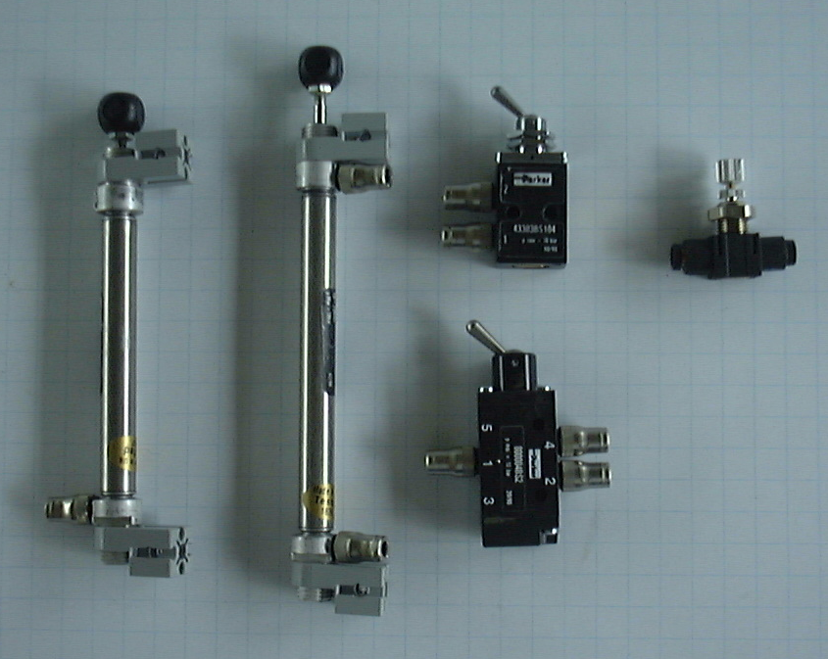
Single Acting Cylinder.

This cylinder has a spring inside which returns the piston rod back to its negative position. When you connect the air supply to the entry port, air enters the cylinder and pushes the rod out into the positive position.

The diagram below shows a schematic representation of a single acting cylinder.

Three Port Valve Pneumatic Symbols

Main Air Supply:

Exhaust Air

Connection to a cylinder

Valve-port shut off

Direction of air flow
Double Acting Cylinder
The circuit shown here introduces five port valve, double acting cylinder and a flow control valve. Double acting cylinders have no spring to make them return so they need to be pushed in both directions.
In the circuit the air supply is connected to port one. Pushing button 'A' switches the supply to port four to send the piston out and pushing button 'B' switches the supply to port two to send the piston in.
The flow control valve is to slow down the action with the cylinder by restricting the outgoing air flow . This piston goes positive at a controlled speed and negative fast.

Flow Control Valve

The piston rod moves very quickly without using a FLOW CONTROL VALVE. This is used to slow the speed of the piston down by reducing the flow of air.

The valve has two routes for air: The by-pass route contains a ball valve. Air flowing form port 1 to port 2 pushes the ball onto a seat and so blocks the by-pass channel. This means that the air has to go through the controlled route. However, air flowing from port 2 to port 1 will push the ball off its seat, and flow freely through the by-pass route.

