
Outline:
Name: Form 9
Y9 Mirror Project
You are required to design and make a small mirror stand which will incorporate a piece of self-adhesive mirror 80mm by 80mm. The mirror stand can be static table mounted or an adjustable version. The main materials will be acrylic, plywood and MDF although you can incorporate other materials into your design. Some pupils will be expected to use Pro-desktop CAD software to draw the chosen idea. You are also expected to use CAD/CAM to produce at least one component for your design. This could be using the Stika Scan or the CNC miller.

- You will be expected to look at existing products and explore how they have been constructed.
- You should also evaluate and disassemble other adjustable products before you start your detailed design work.
- Investigate where and why mirrors are used, and from the results identify a situation for which you can design a solution.
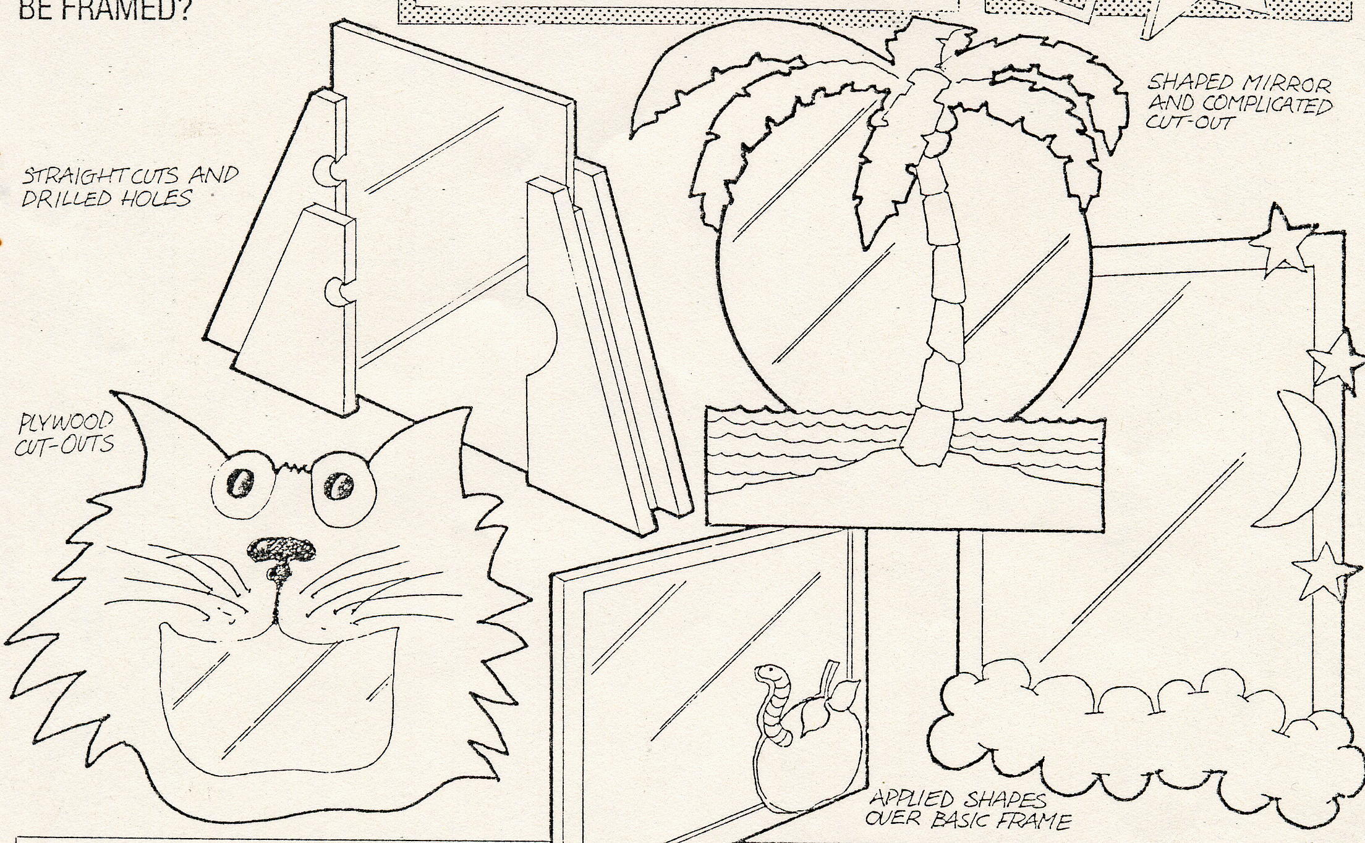

Assessment:
This is your major assignment for Y9 Manufacturing, and is called a Design and Make Assignment (DMA). Your teacher will assess your work against the National Curriculum. At the end of your project your teacher will award you a level for designing and a level for making. Your teacher will be looking at the quality of designing and making work over the assignment.
Teacher Assessment.
Designing: Making: Effort:

