NEAB GCSE Systems & Control
See Mrs Stevenson

Systems and Control is about electronic, mechanical and computer controlled systems. You will investigate a number of different systems and use computer control software to design and model complex systems. You will gain an understanding of how Peripheral Interface Controllers (PICs) are programmed and used to operate systems.
The course involves the use of electronics and mechanisms in the design and manufacture of products. You will also use Computer Aided Design to manufacture products using CNC equipment. You should have a good understanding of mathematics if you opt to follow this course.
A high degree of self-motivation is essential, as you will carry out a great deal of research in your own time. You will need to be able to generate design proposals, draw up accurate specifications and present all your work to a high standard. The use of I.C.T is also a requirement of this course.

Remember: Technology is about Designing and Making.
You will be expected to produce a large amount of design work in your own time at home.
All GCSE students undertake a main project starting at Easter in Year 10 and finishing in February in Year 11. This project represents 60% of the final examination mark.
Teachers of Manufacturing, Graphics and Food will show examples of the work involved. Look on the department web site for examples of work undertaken at KS4.


look on the school intranet
Year 9 into Y10
Design technology
Design Technology is compulsory in Y10 & Y11. You have to select one course from this booklet to study during Key Stage 4.

You should discuss your options with your parents and your Design Technology teacher, who will advise you on the course that suits your capabilities and for the career route that you want to follow.

See Mr. Gell,
Head of Design Technology,
if you need more advice.

NEAB GCSE Food Technology
See Mrs McLoughlin or Mrs Barker.

Modern food production is a huge, fast moving business. New products are continually being developed, using many kinds of complex technologies. Food Technology is about using knowledge of food production, processing and making to develop your ideas for new food products and understanding how food is produced safely on a large scale.

You must enjoy practical food preparation and be prepared to bring ingredients when asked to. You should be interested in investigation work, as there are many links with food science. This involves a scientific study of safety, hygiene, nutrition and the equipment and processes involved in food preparation. The course will also look at market forces and the industrial applications of product manufacture.

A high degree of self-motivation is essential, as you will carry out a great deal of research in your own time. You will need to be able to generate design proposals, draw up accurate specifications and present all your work to a high standard. The use of I.C.T is also a requirement of this course.

Food Technology is examined through a piece of practical coursework and a final written examination. 60% of marks are awarded for a final piece of practical work and a design folder. 40% of marks are awarded through a single written examination paper.

NEAB GCSE Resistant Materials
See Mr Allen or Mr Gell

Resistant Materials is about designing and making objects largely through the use of wood, metal and plastics. In this course you will make items from materials that need cutting, joining, drilling, and bending. You will also use Computer Aided Design to manufacture products using CNC equipment.

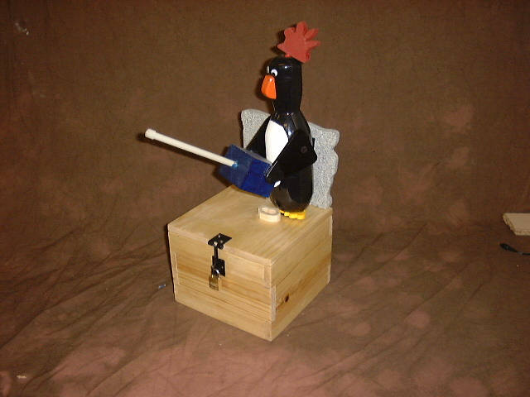
The course is aimed at encouraging you to combine designing and making skills with knowledge and understanding, both to produce quality products and critically evaluate existing products. You will be taught about modern industrial techniques of manufacturing products.

In the early part of year ten you will undertake a number of small design and make assignments aimed at improving skills. You will be required to design and produce detailed notes and drawings for objects you are asked to make. Most of the latter part of the course is of a practical nature.

Resistant Materials is examined through a piece of practical coursework and a final written examination. 60% of marks are awarded for a final piece of practical work and a design folder. 40% of marks are awarded through a single written examination paper.

NEAB GCSE Graphic Products
See Mrs Norman or Mr Allen

Graphic Products is about designing and model making and concentrates on the development of your ideas, with a big emphasis on drawing and model making.
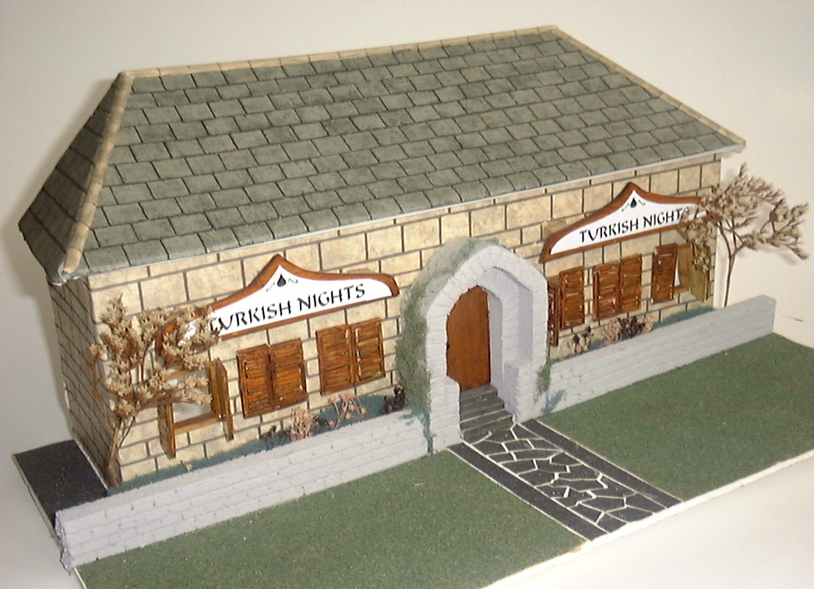
You must enjoy drawing with pen, pencil, and markers - both in a loose freehand style and in formal detailed fashion. Model making is a major part of the course and you will also use computers to design and make products.

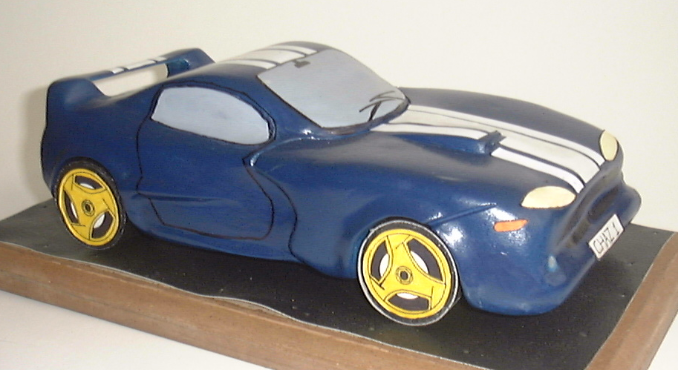
The course focuses on the ability to communicate ideas, instructions and information. The subject is taught through real life problem solving situations such as illustration, advertising, display, exhibitions, manufacturing and printing.

Students should be aware that a time commitment at home is necessary in order to produce work of a high standard.

Graphic Products is examined through a piece of practical coursework and a final written examination. 60% of marks are awarded for a final piece of practical work and a design folder. 40% of marks are awarded through a single written examination paper.

